Click ‘Create a resource’

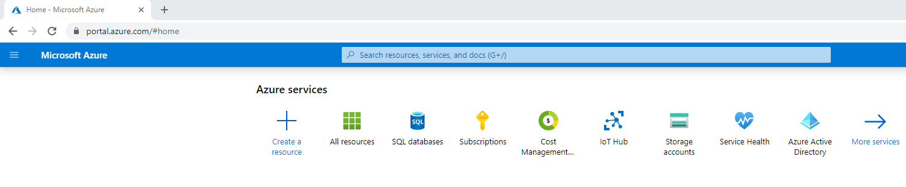

Click Analytics then ‘Data Factory’:

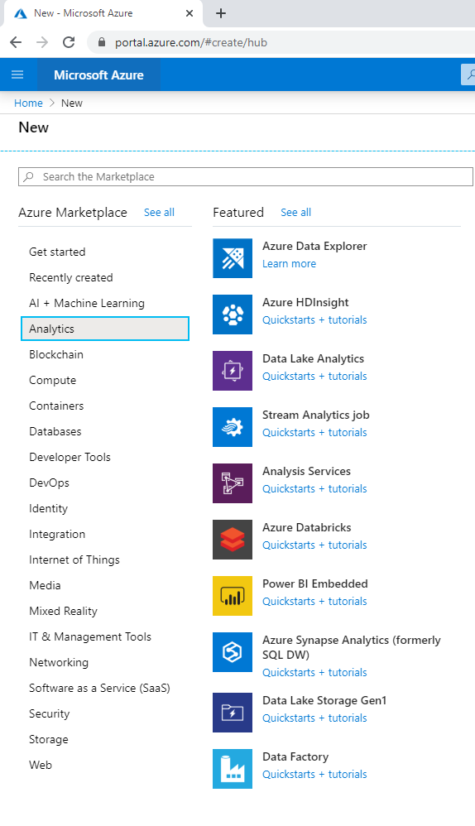

Complete the form, then click Create:

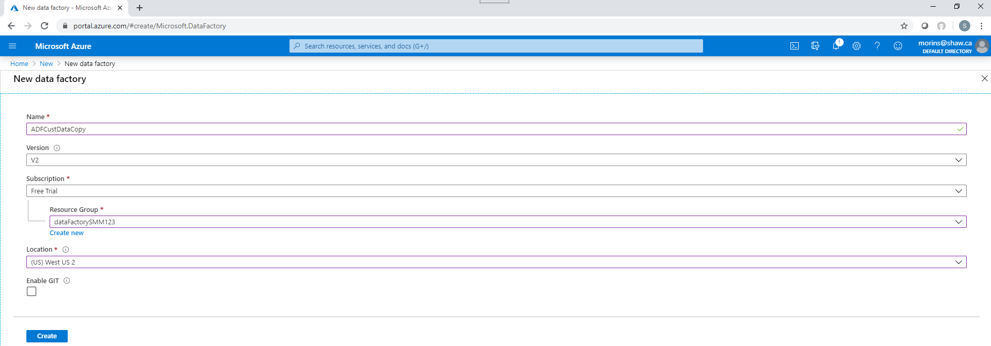

The deployment will start, in progress status is shown below:

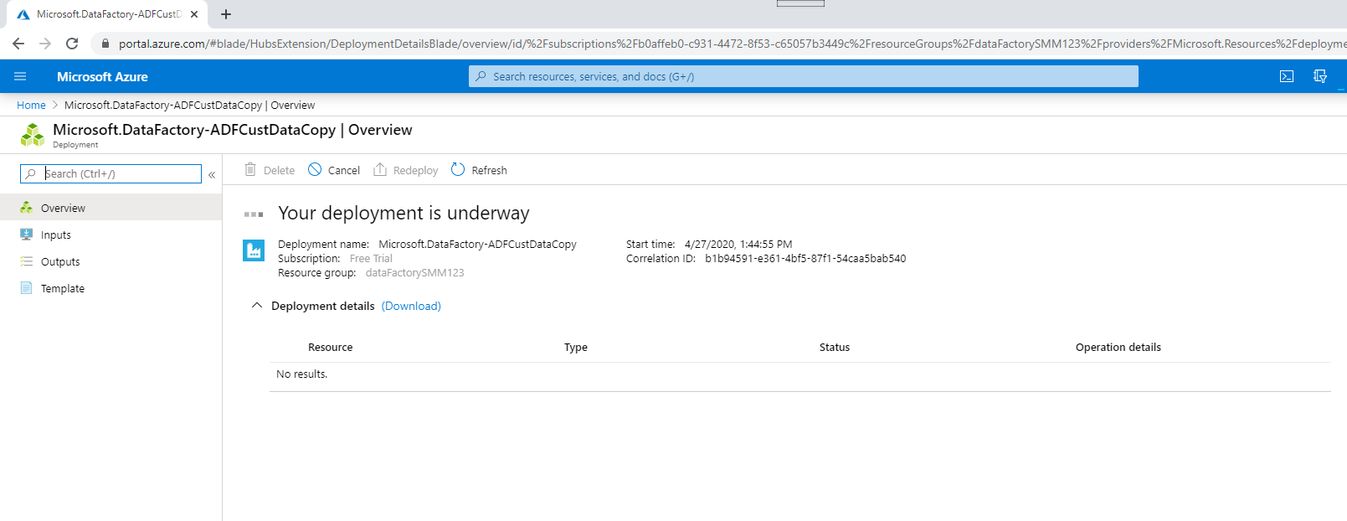

The deployment has completed, click go to resource:

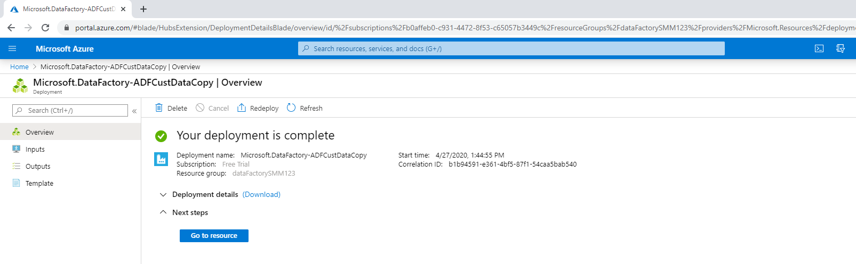

The Overview tab will be displayed, click ‘Author and Monitor’:

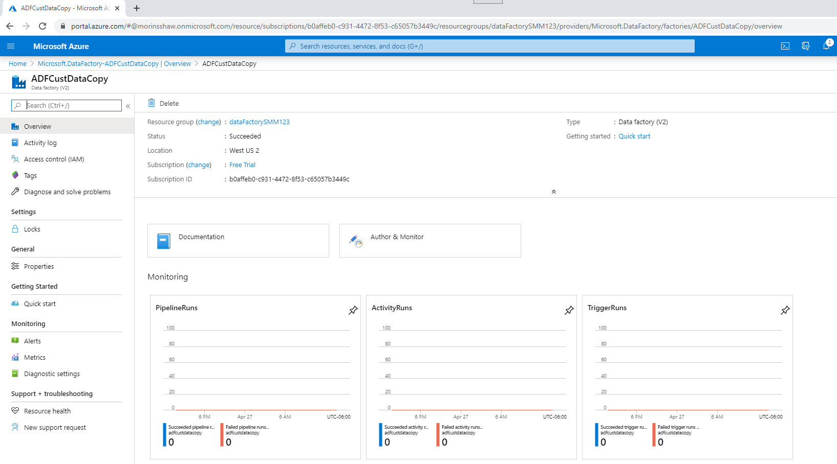

Click the ‘Copy Data’ option: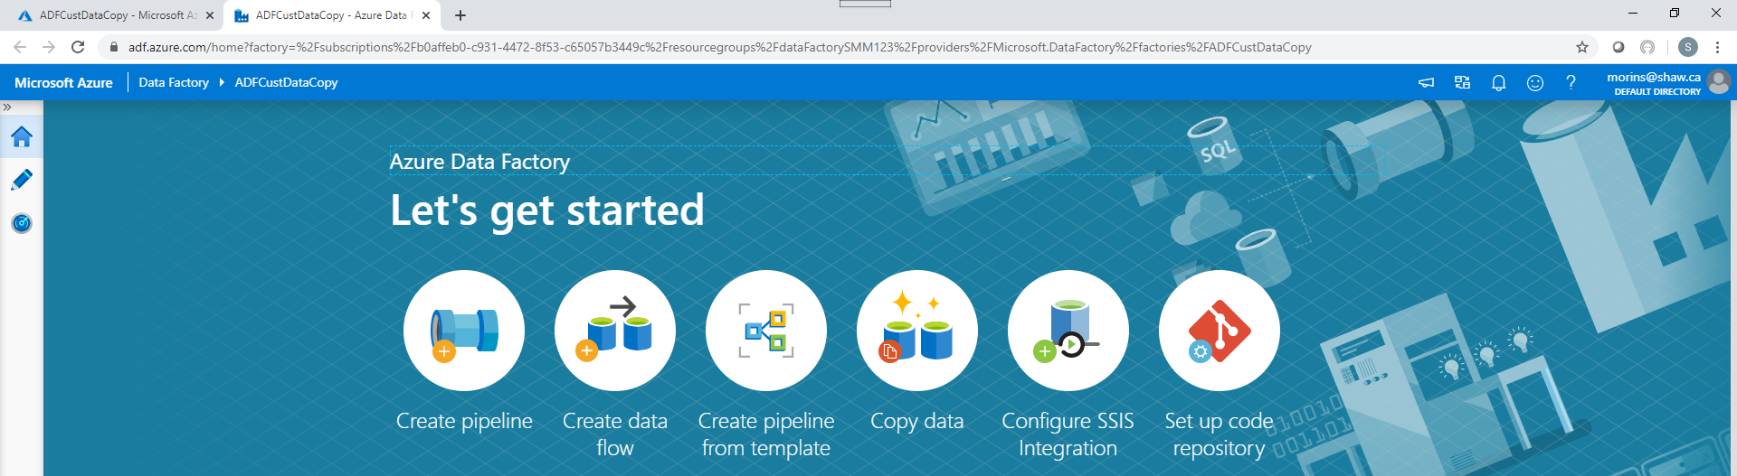

Fill in each section of the Copy Data wizard, begin with properties:

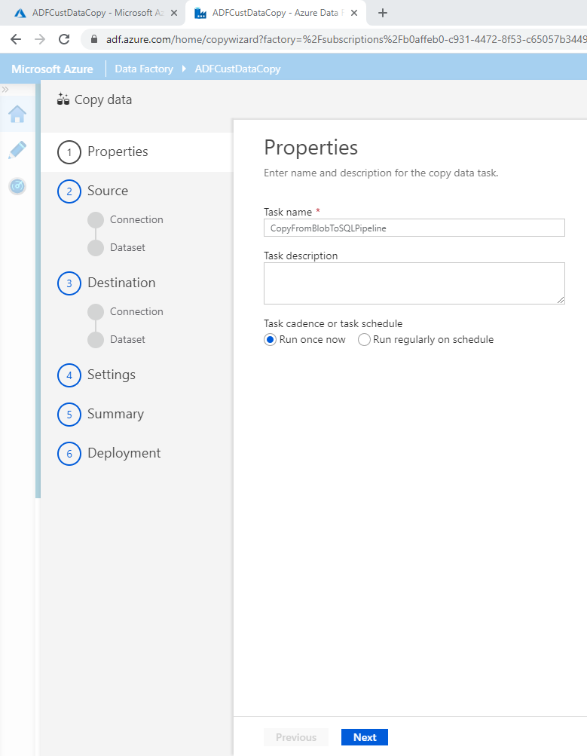

Fill in Source details:

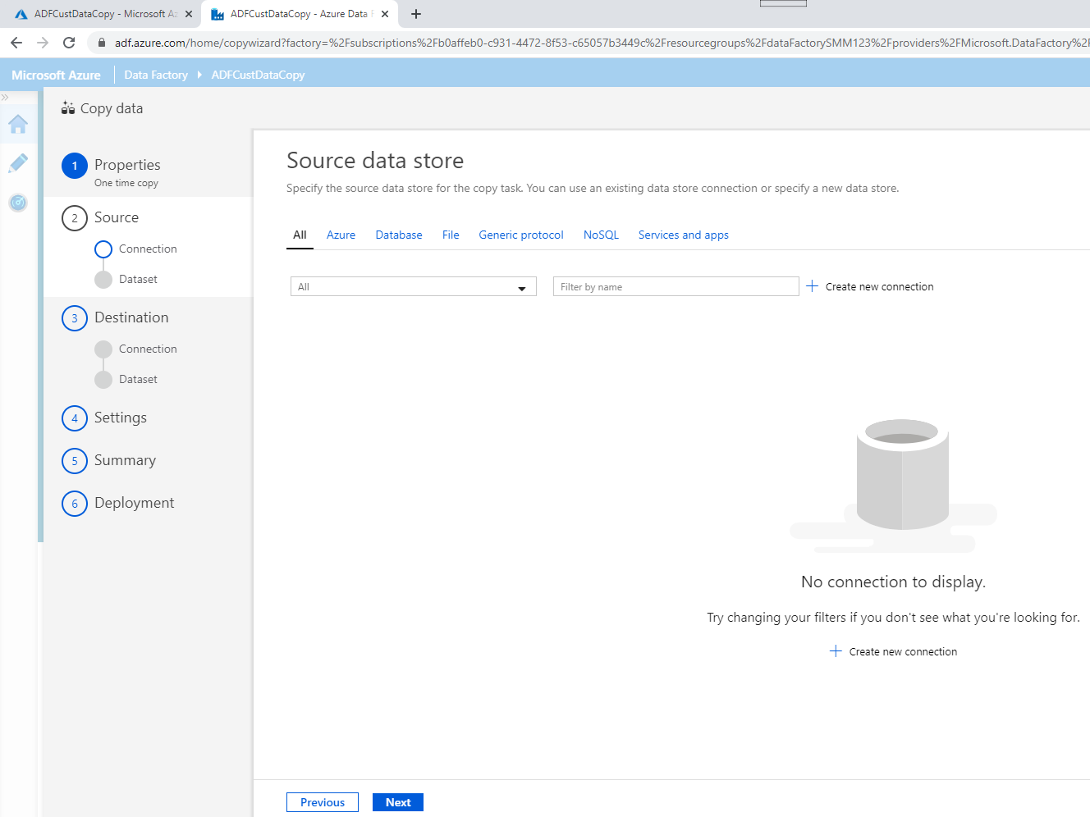

Create linked service for source data (Azure data lake gen2):

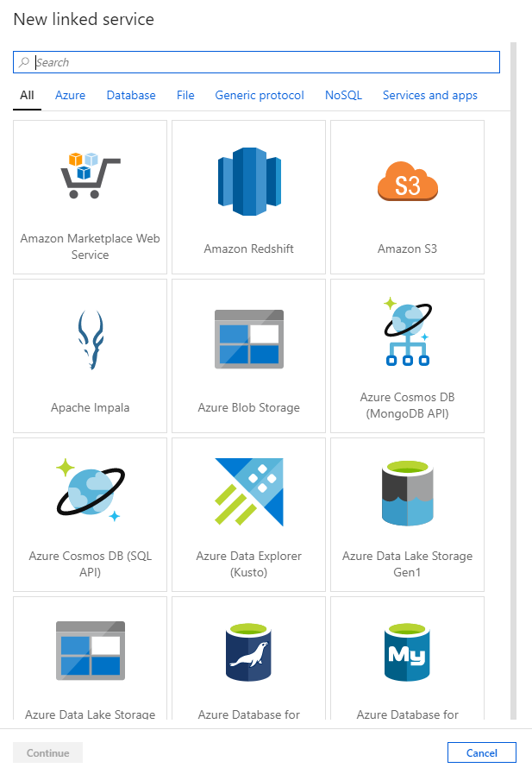

Fill in details of the linked service:

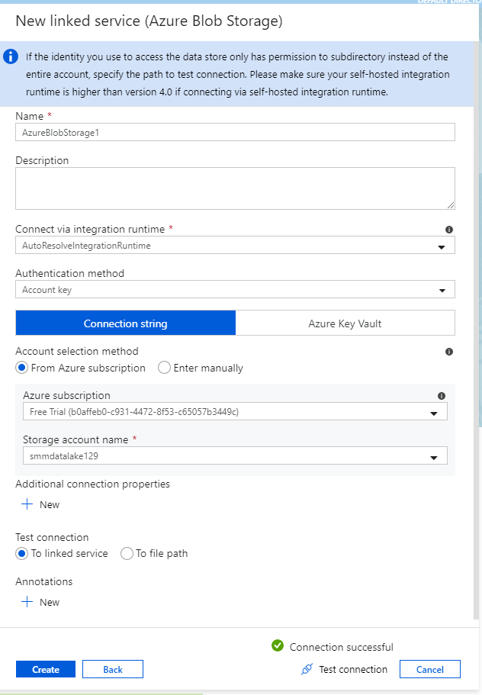

Configure input folder and file:

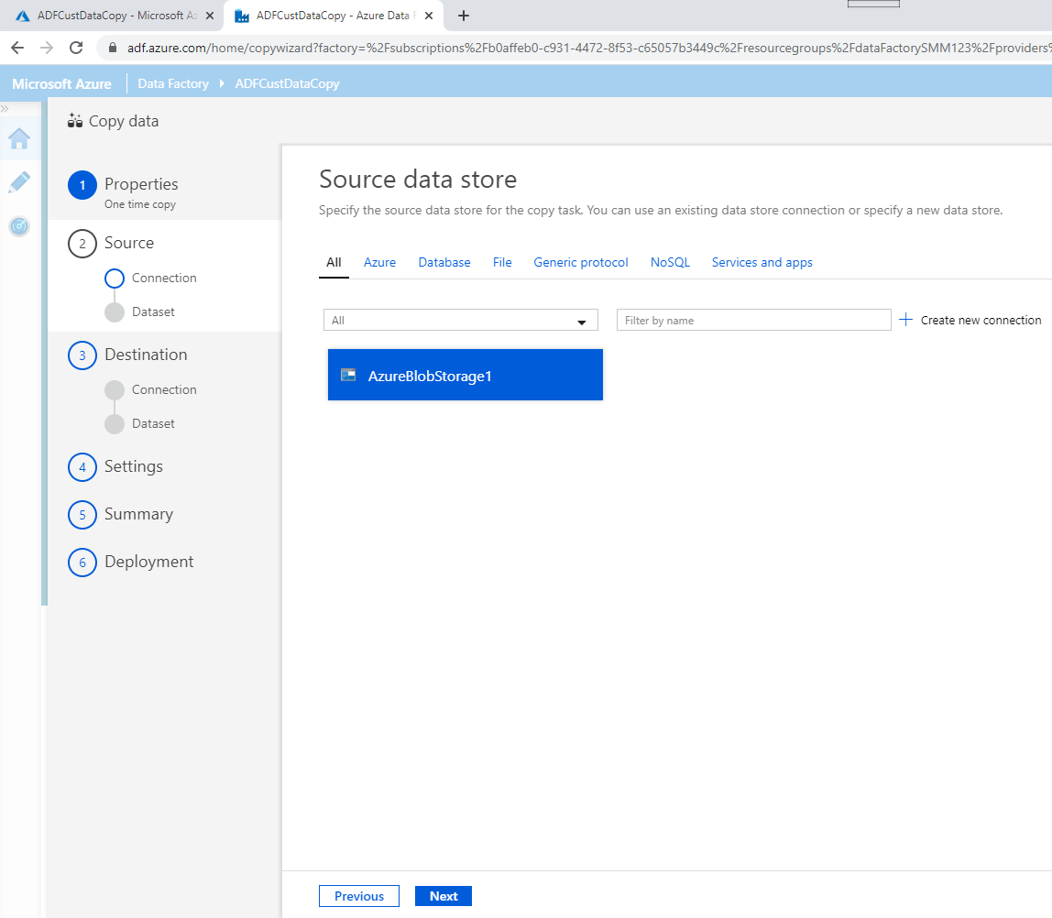

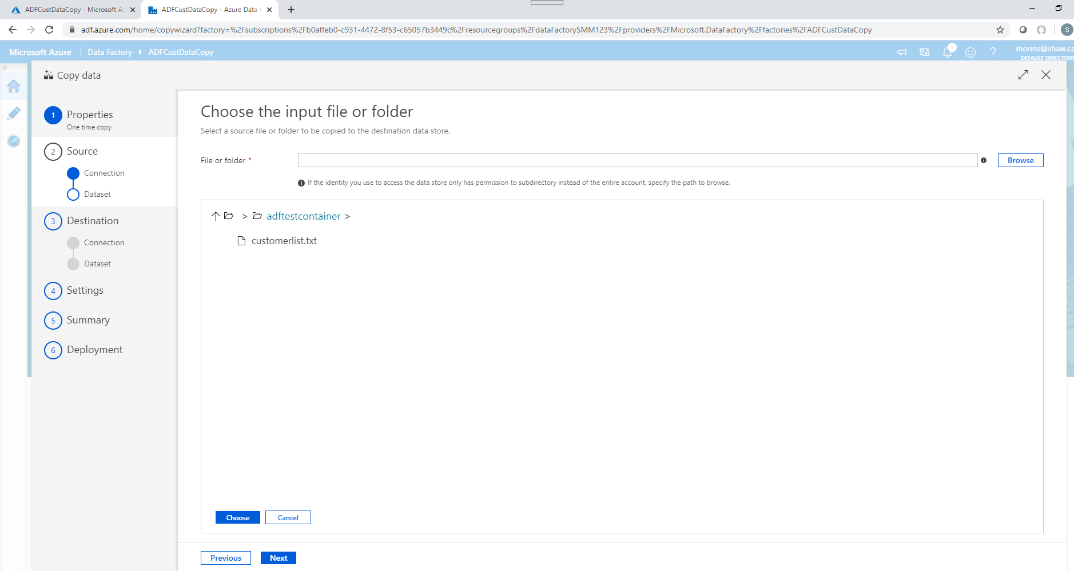

Configure file format settings:

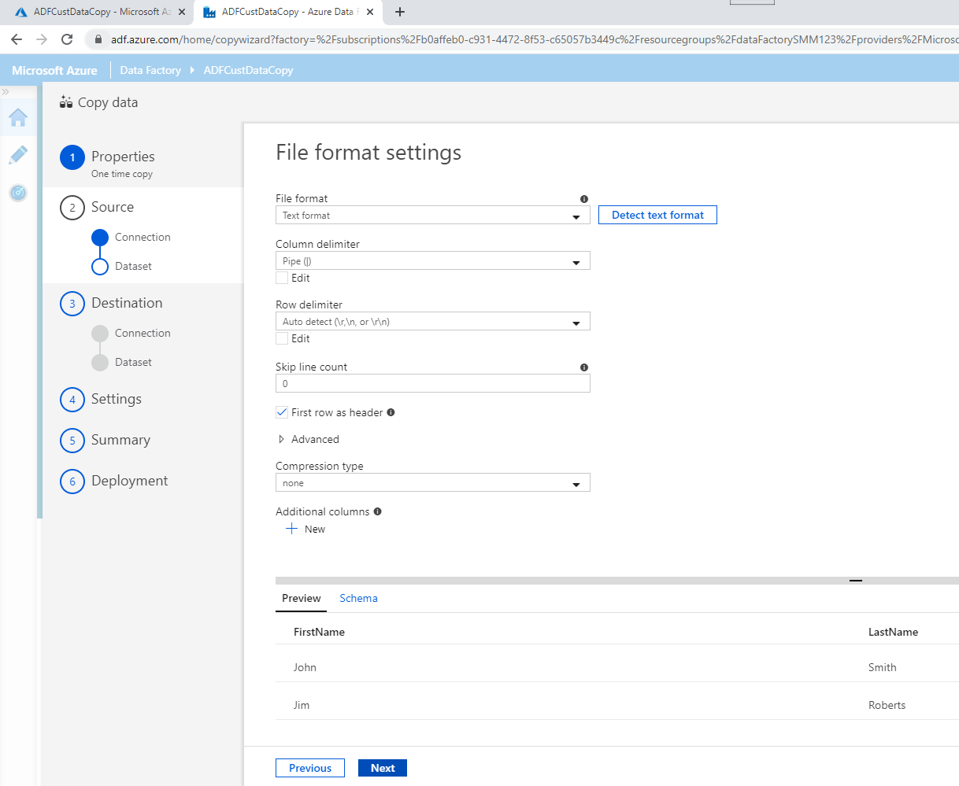

Configure destination data store:

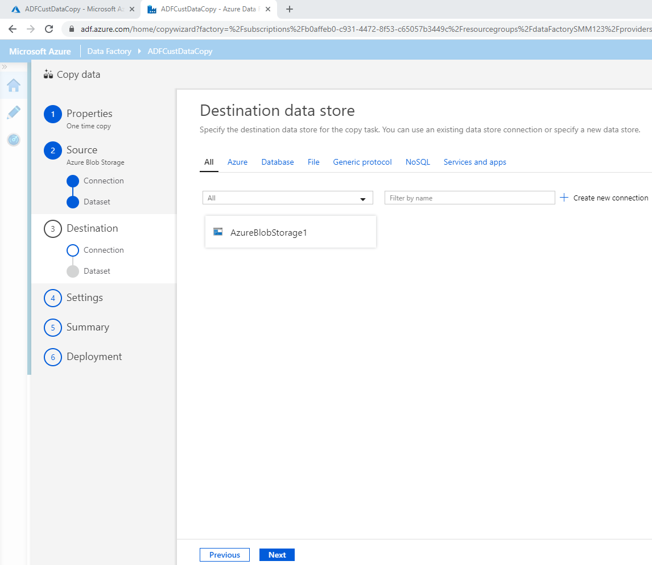

Create new linked service for Azure SQL DB:

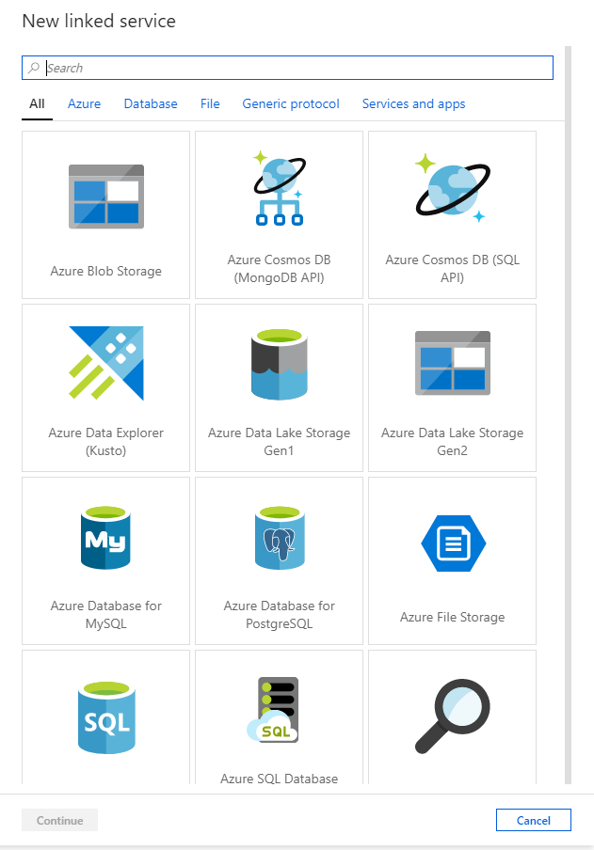

Complete details of Azure SQL DB service:

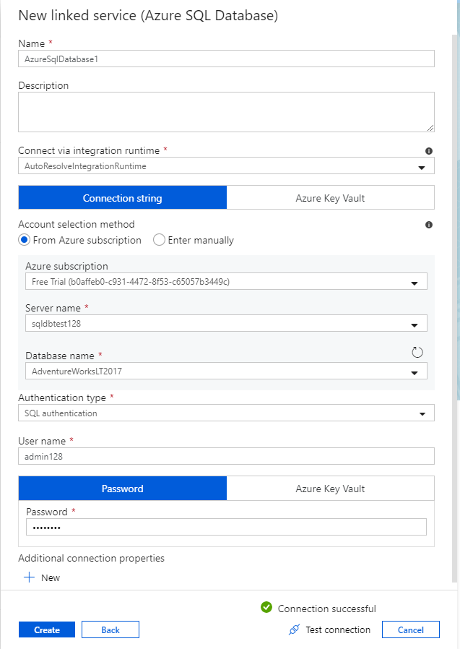

Configure details of destination data store:

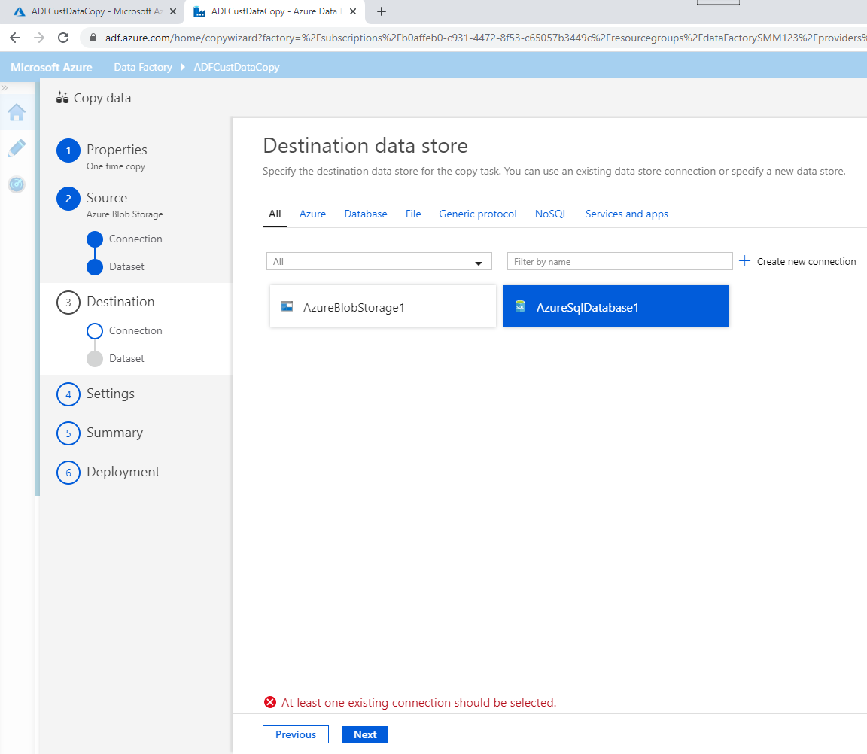

Configure table mapping:

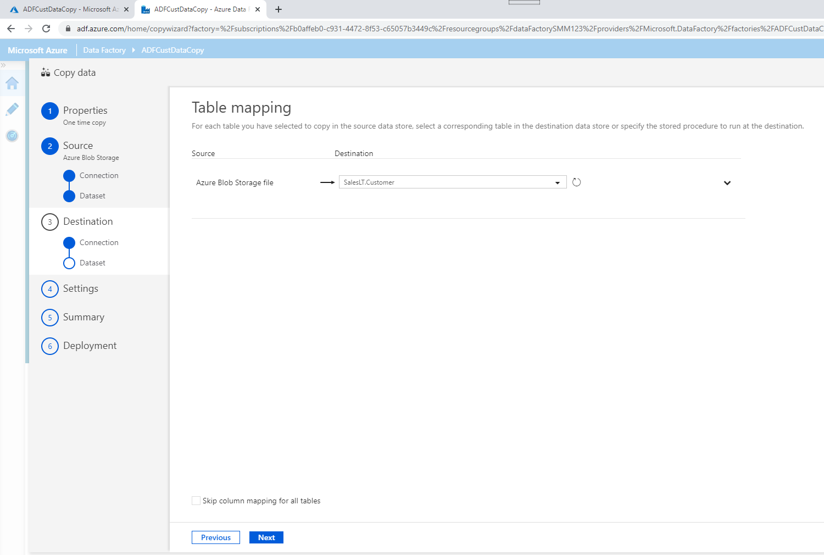

Configure column mapping:

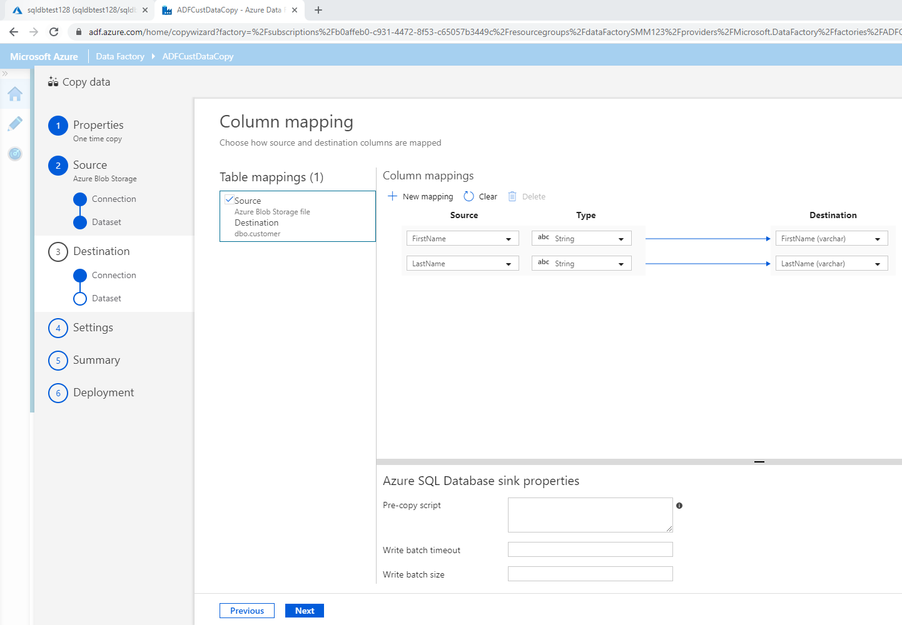

Configure Settings:

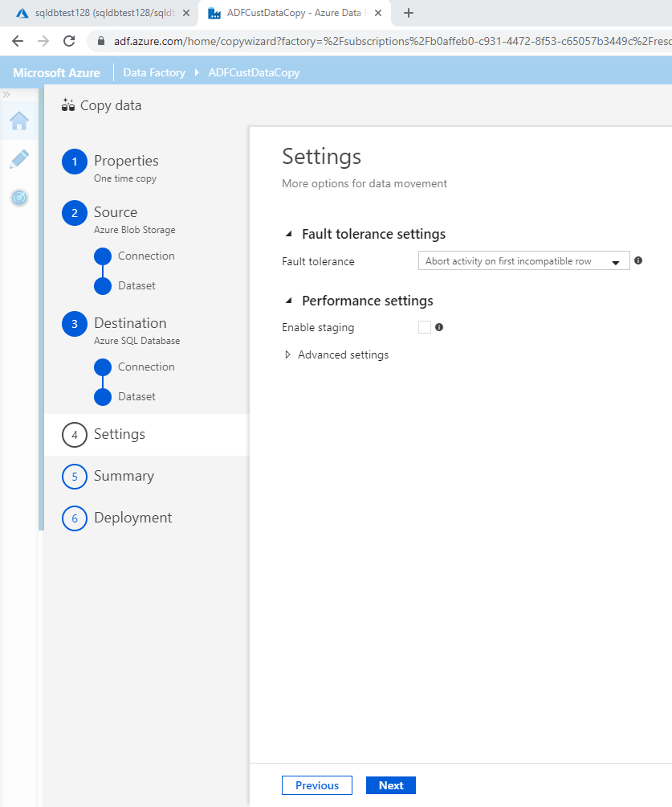

Review summary:

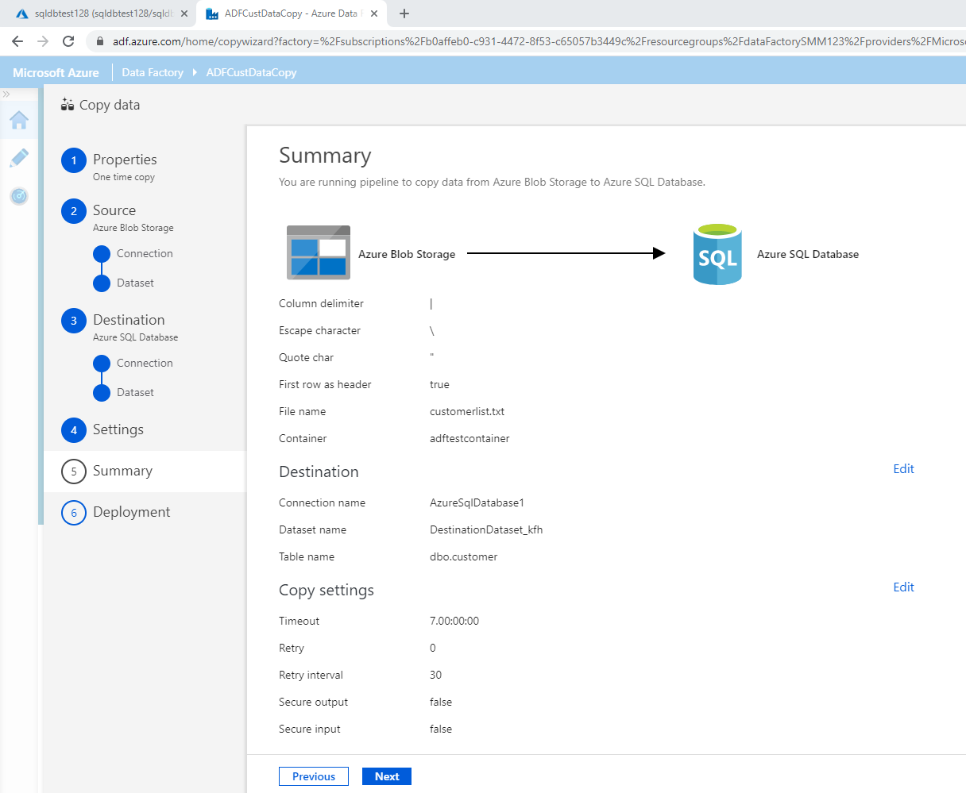

Click Next and then deploy. The deployment will begin:

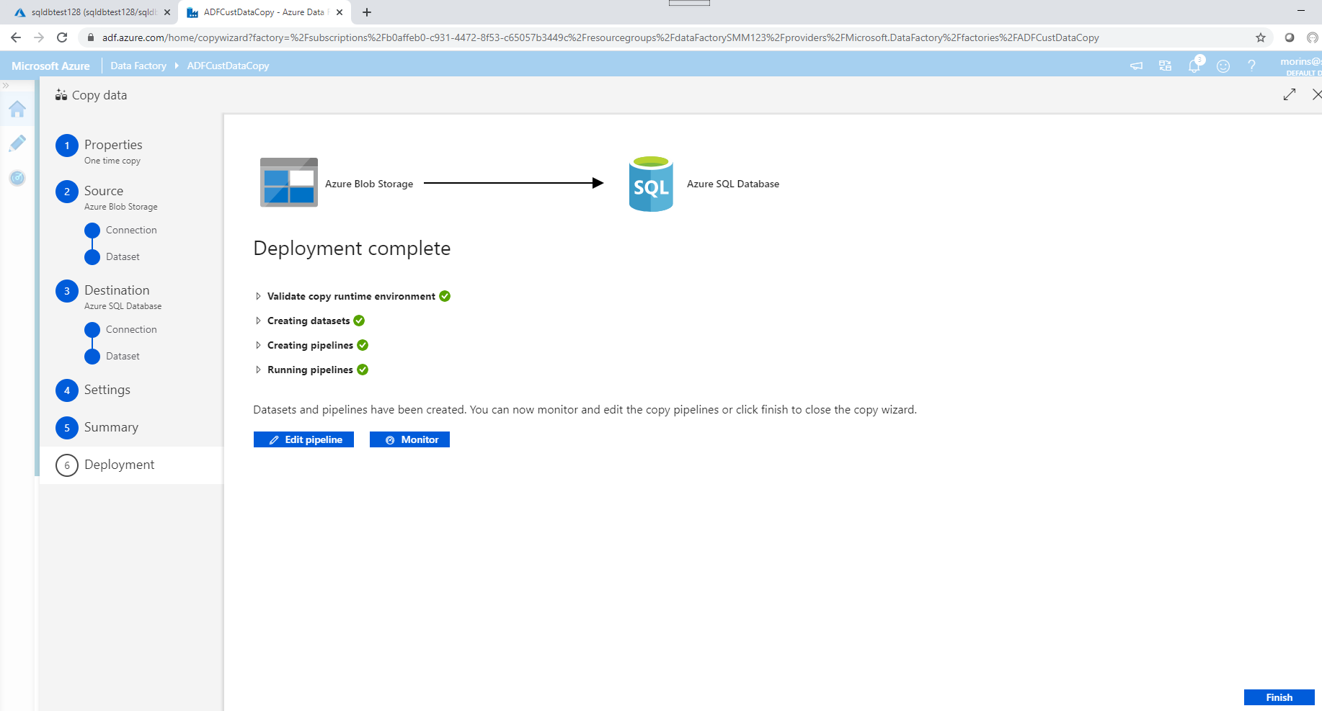

Review pipeline run status:

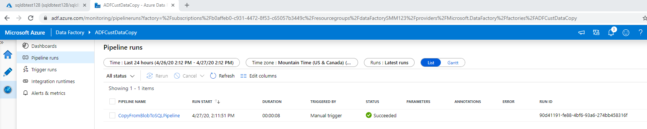

A successful pipeline run is shown below:

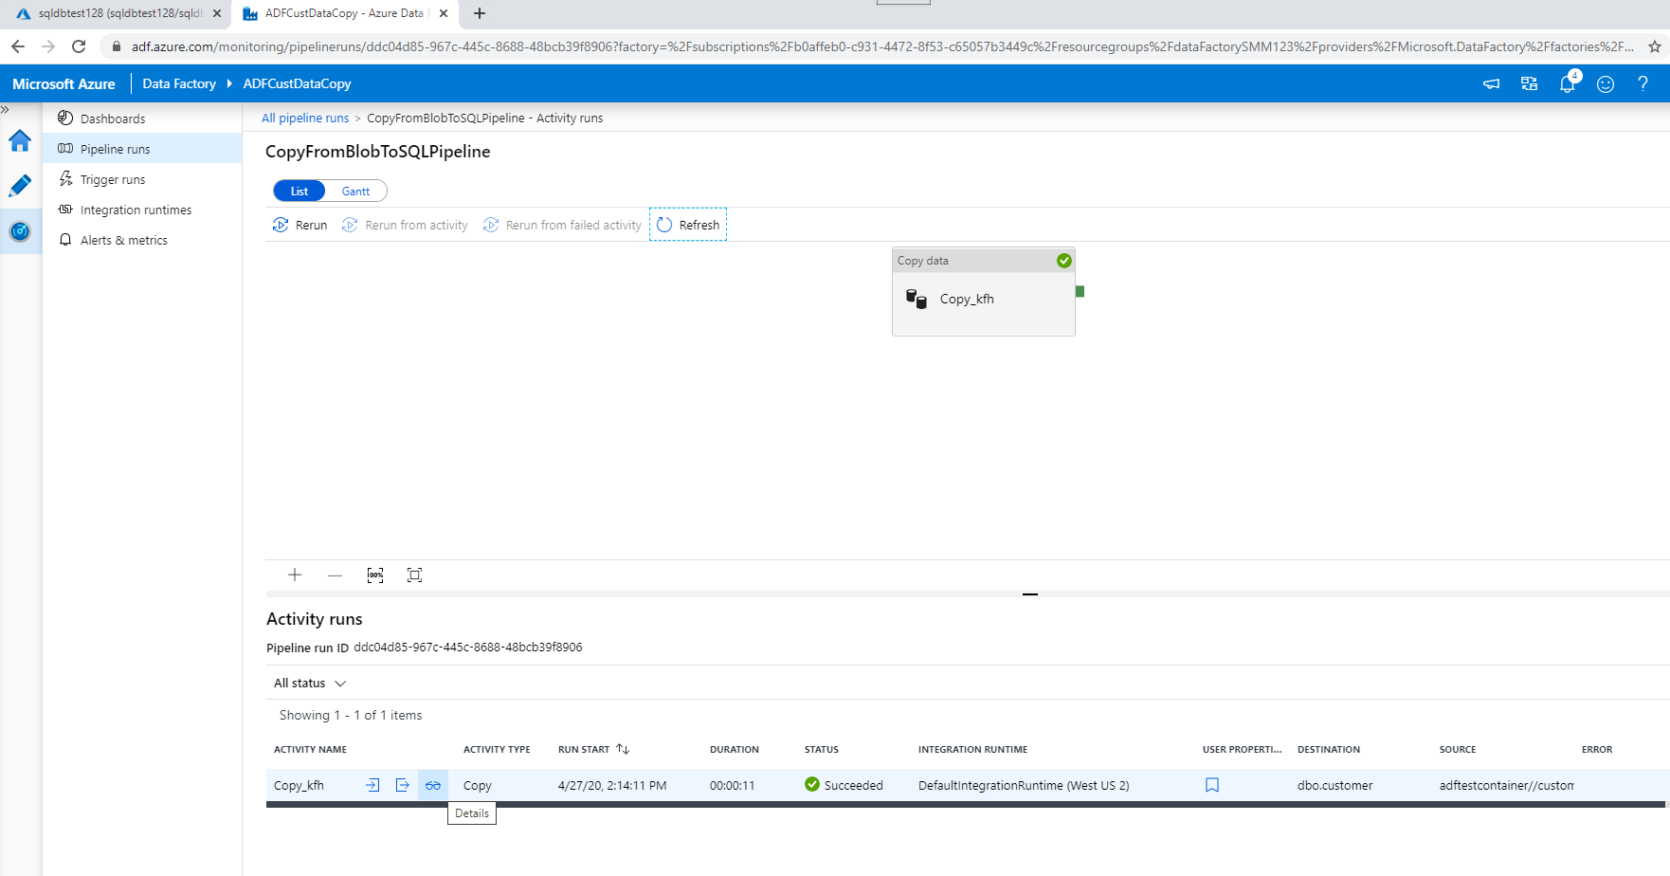

Click on the eyeglasses in the Activity runs to see the details of that run:

